Terms of Reference

Version 2

(all changes marked yellow)

for

Selection of a qualified and experienced solar energy EPC company for the design, supply, installation, and commissioning of a 238 kWp Agri-PV system at the IARI Campus, New Delhi

Brief Tender Notification
Particulars | Description
Location of Performance | Latitude- 28°37'48.5"N, Longitude- 77°09'34.8"E IARI Pusa Campus, New Delhi, 110012.

Abbreviations

Agri-PV: Agriphotovoltaics
kW: Kilo-Watt
LT: Low Tension Side
BoS: Balance of Systems
EPC: Engineering, Procurement and Construction
PAR: Photosynthetically Active Radiation
SAT : Single Axis Tracking
SCADA : Supervisory Control and Data Acquisition
VPD: Vapor Pressure Deficit

TERMS OF REFERENCE

Background and context:

Agrivoltaics is a promising approach at the intersection of renewable energy, food and water security. Installing solar panels on agricultural land allows for the dual use of land: It allows the production of solar energy (climate mitigation) and agricultural activities on the same piece of land, increasing land use efficiency compared to agriculture or solar energy production in isolation. The shade provided by solar panels enables high-yield horticultural models that increase crop yields while conserving precious water resources (climate adaptation). In countries with a large agricultural economy, such as India, widespread adoption of solar energy is expected to lead to competition for land. However, Agrivoltaics has the potential to create synergies between the country's solar energy and agricultural goals.

As an emerging economy, India's electricity demand is increasing rapidly. To reduce greenhouse gas emissions, the Indian government has set an ambitious target of 500 GW of installed non-fossil fuel-based capacity by 2030, with around 300 GW coming from solar energy alone. Agri photovoltaics (Agri-PV), the simultaneous use of arable land for agriculture and electricity generation through solar photovoltaics, can play a key role in reaching this target. This approach offers the potential to mobilise additional land for the expansion of solar-based power generation while ensuring food security and avoiding potential land conflicts. Through the expansion of Agri-PV in India, farmers and rural communities will be empowered to play an active role in India’s energy transition and benefit through new employment opportunities, increased and more diversified incomes. Their resilience to climate impacts is enhanced through crop protection, and improved microclimate and water regulation. The main identified barriers to the uptake of Agri-PV in India so far are the lack of scientific data on India-specific contexts, awareness, capacities, suitable business models and financing instruments as well as clear legal and policy frameworks.

The Government of India is now exploring possibilities to further increase the multipurpose usage of land by co-location of agriculture and solar PV. A major step forward to find a common solution for promoting the co-location of solar PV and agriculture in India was raised in July 2019 by the Union Finance Minister in the Parliament, stating that “Annadata [farmer] can also be urjadata [producer of energy]”.

Purpose of the Tender
The purpose of this tender is to Select a qualified and experienced solar energy EPC company for the design, supply, installation, and commissioning of a 238 kWp Agri-PV system at the IARI campus in New Delhi, India.

Technical Specifications and Special Conditions Detailed Scope of Work
The scope of work includes turnkey design, supply, installation, and commissioning of a 238 kWp AgriPV project at IARI in Delhi, India. The 238 kWp project will comprise of 2 separate systems –
- 115 kW Agri PV Polyhouse with single axis trackers & climate-controlled cultivation
- 123 kW fixed tilt Agri PV system with open field cultivation
The selected bidder should make available the required equipment as specified and as per the specifications listed in table 1 of the ‘technical specifications section with the standards mentioned in table 2.

The selected bidder will be responsible for the following tasks mentioned below:
- a. Supply of 115 kW Single Axis Tracking Agri PV System:
Specifications of the project are listed below:
  - min. 590 Wp Bifacial solar panels
  - String inverters of adequate size ensure that there is no cut-off at any point of time of generation. Assume 20% tracker gain & 15 % max bifacial gain. Structure for mounting the string inverter and all other inverter accessories.
  - 115 kWp Single Axis Tracking (SAT) system in 1P/2L configuration with EW tracking and South tilt of at least 5 degrees with following specs:
    - Layout: 7 rows 28 panels each. (7x28x590 =~115kWp)
    - System elevation – centre of panel elevated exactly 5.5m from the ground.
    - Intra row column-to-column distance (Pitch) – exactly 5.7m
    - Column-to-column distance within rows -min. 5 m
  - All mounting hardware for structures including the module mounting clamps
  - Evacuation of power 300m from project site on LT side
  - DC cables, AC cables, Earthing cables
  - All Electrical BoS including but not limited to MC4 connectors, DCDB & ACDB, earthing materials, lightning arrestors, conduit pipes, combiner boxes, etc.
  - Foundations for all column posts: No concrete shall be used in the crop cultivation area for the foundations. In such areas, bidders shall use screw piles, rammed posts, ground anchors, or equivalent reversible foundation solutions. The bidder shall review the geotechnical information, soil data, and ground test results provided in Annexure A and shall determine the required ramming / embedment depth accordingly. Any supplementary verification tests required by the bidder for finalizing the foundation design shall be carried out at the bidder’s cost. The final foundation design shall comply with applicable Indian and international standards.
  - All materials required for construction of the control room with attached toilets, irrigation pump room, and storage room
  - Weather & data monitoring system with the following sensors: radiation, PAR, soil quality, water quality, soil moisture, dendrometer, air temp, leaf temp, soil temp, panel surface temp, rain gauge, wind velocity & direction, CO2, VPD
  - Farm controller with electrical panels connected to the sensors and all equipment related to dynamic mgmt. of the light & microclimate control
  - SCADA system for solar monitoring
  - PIC plast polyfilm cum rain protection kit for 0.6 acre roof coverage with automated motorized retraction mechanism from Cravo or equivalent along with all wire ropes & accessories
  - 40 mesh insect net for 0.6 acre roof coverage along with wire ropes & accessories
  - 40 mesh insect net for side walls – area based on 0.6 acre roof coverage and 5.0m height
  - Weed mat for 0.6 acre floor coverage
  - Air circulation fans for 0.6 acre as per conventional distance between fans
  - High pressure pump set for irrigation, fertigation, fogging, and sprinklers for panel cleaning
  - Drip irrigation & fertigation system for 1 acre farming (includes the 123 kW fixed tilt system) including filters, venturi, all valves, piping network, and driplines. Timer based control
  - Sprinkler based cleaning system with all associated nozzles, pipes, and valves
  - High pressure fogging system with 40 microns mist including pipes & automation via controller
  - Agronomical & mechanical instruments including trolley for reaching the panels & for harvesting the crops
  - Trellising system for 0.6 acres connected with the mounting structure columns

- Supply of 123 kW Fixed Tilt Agri PV System:
Specifications of the project are listed below

  - min. 590 Wp Bifacial solar panels
  - String inverters of adequate size ensure that there is no cut-off at any point of time of generation. Assume 15% max bifacial gain.
  - 123kW fixed tilt mounting structure in 1P configuration
    - Evacuation 300m from project site on LT side
    - Layout: 10 rows × 21 modules =~ 123kWp
    - System elevation: exactly 4.0m elevation from the lower edge of the panel
    - Intra row column-to-column distance (Pitch) – exactly 5.7m
  - Column-to-column distance within rows -minimum 5.0m
  - Foundations for all column posts. No use of concrete to be used in crop cultivation area for the foundations – use screw piles, rammed posts, ground anchors, or equivalent
Note: The “no concrete” requirement is intended specifically for solar mounting structure foundations located within the active crop cultivation zones. For the control room, irrigation pump room, storage room and other non‑crop structures concrete can be used.
  - All mounting hardware for structures including the module mounting clamps
  - Evacuation of power 300m from project site on LT side
  - DC cables, AC cables, Earthing cables
  - All Electrical BoS including but not limited to MC4 connectors, DCDB & ACDB, earthing materials, lightning arrestors, conduit pipes, combiner boxes, etc
  - Foundations for all column posts. No use of concrete for the foundations – use screw piles, rammed posts, ground anchors, or equivalent
  - Sprinkler based cleaning system with all associated nozzles, pipes, and valves
  - SCADA system for solar monitoring
  - Trellising system for 0.4 acres connected with the mounting structure columns

Material delivery & Testing
  - Packing, Loading, Transportation and supply of materials as per bill of materials.
  - Customs clearance and domestic transport must be handled by the bidder.
  - All goods must already have been manufactured in India by the tenderer or fully imported for customs purposes. It may kindly be noted that GIZ India does not possess an Import Export Code (IEC). Accordingly, if any proof or documentation related to the IEC is required, GIZ India will not be in a position to furnish the same. The bidder remains clearly responsible for custom clearance for DDP on the site.
  - The bidder is importer and must have an own valid IEC. That bidder is responsible for customs clearance, duties, and compliance.
  - All the parts and materials should fulfil the requirement of turnkey EPC (Engineering, Procurement and Construction) of project.
  - Inspection of materials shall be done at vendor premises.
  - All the cost associated with the inspection of materials shall be borne by vendor only.
  - Vendor will inform about readiness of materials at least 1 week before the inspection.
  - Performance / quality warranty of materials as required for the project.
  - Any other materials required to complete the project.

Installation of the Agri PV Systems:

  - Turnkey installation of the complete AgriPV systems including the column post foundations for both the 115 kW Single axis tracker Agri PV system & 123 kW fixed tilt Agri PV system in accordance with the approved design by GIZ and as per the supply BoQ
  - Arrange necessary machinery to install all parts of the system at the required heights. This may include hydra, manlift, tractors, platform ladders, hydraulic tensioners etc.
  - Turnkey Installation of all agri infrastructure including irrigation system, fertigation system, fogging system, sprinkler system.
  - Installation of all nets, polyfilms, weed mats, and automation systems including SCADA, Data monitoring system, control panel, and electrical panels.
  - Adhere to safety standards and regulations.
  - Ensure completion of all general works involved including land grading, electrical trenches, fencing, lighting, drainage trenches, earthing pits, lightning arrestor, control room, irrigation 7 fertigation pump room, and storage room.

Quality Assurance and Control

  - Implement a robust quality assurance and control process throughout the project lifecycle. Must provide a detailed quality control & inspection plan for both supply & installation.
  - Conduct regular inspections and testing to ensure the reliability and performance of the solar PV system.

Coordination with Agricultural Experts

  - Collaborate with agricultural experts to ensure the AgriPV system is integrated seamlessly with farming activities.
  - Implement measures to minimize any adverse impact on agricultural practices.

Commissioning

  - Undertake the commissioning of the AgriPV systems, including system testing and performance validation.
  - Provide structured training to IARI and GIZ‑nominated at least 2 users and maintenance personnel, including at least one on‑site training session of minimum 1 full working day covering system operation, safety, SCADA use, and routine O&M, and handover of detailed O&M manuals.
  - Ensure tracking control is working as per specifications

Documentation and Reporting
  - Maintain detailed documentation of the entire project, including design drawings, technical specifications, and installation records.
  - Submit regular progress reports and updates to GIZ.
  - Maintain open and transparent communication with GIZ throughout the project.
  - Coordinate effectively with relevant stakeholders, subcontractors, and third parties involved in the project.

Warranty and Maintenance
  - Provide a comprehensive warranty for the installed Agri-PV system for a period of 5 years
  - Offer a maintenance plan with scheduled inspections and prompt resolution of any issues during the warranty period.

Regulatory Compliance
  - Ensure compliance with all relevant local, state, and national regulations and standards governing solar energy installations.
  - Obtain necessary permits and approvals for the Agri-PV project.
  - Implement measures to minimize environmental impact, including proper disposal of waste materials and adherence to environmental regulations.

O&M services & Post-Installation Support
  - O&M for a period of 1 year including requirement of spares.
  - Offer post-installation support and troubleshooting services as needed.
  - Respond promptly to any issues or concerns raised by GIZ or end-users.
  - Fault Response Time:
Critical faults: within 6–12 hours of reporting
Non-critical faults: within 24 hours
  - Fault Resolution Time:
Critical faults: within 24–48 hours
Penalties shall apply for delays impacting generation.
  - The bidder shall establish and maintain a robust service support system, including local presence, trained technical staff, inventory of essential spare parts, and necessary diagnostic tools, to ensure adherence to the specified response and turnaround times under all operating conditions during the contract period.
  - The bidder shall carry out preventive maintenance at regular intervals (every 3 months), including module cleaning, structure inspection, inverter checks, and electrical safety audits.
  - A list of requisite spares along with spare set of PV modules be indicated, which shall be supplied along with the equipment. A minimum set of spares shall be maintained in the plant itself for the entire period of Warranty, Operation & Maintenance which upon its use shall be replenished.
  - All foreseeable spare parts, as well as those specified or recommended by the manufacturer, must be included in the quotation.

Force Majeure
Force Majeure Events shall include the following events to the extent they satisfy the foregoing requirements:
- Natural disasters, including but not limited to lightning, earthquake, volcanic eruption, landslide, flood, cyclone, typhoon, tornado
- any act of war (whether declared or undeclared), invasion, armed conflict or act of foreign enemy, blockade, embargo, revolution, riot, insurrection, terrorist, or military action
- any pandemic (including Covid-19)
- any requirement, action or omission to act pursuant to any judgment or order of any court or judicial authority or Statutory Entity in India of any Law or any of their respective obligations under this Agreement.
- expropriation and/or compulsory acquisition of the Project in whole or in part by any Government or Statutory Entity
- radioactive contamination or ionizing radiation originating from a source in India or resulting from another Force Majeure Event excluding circumstances where the source or cause of contamination or radiation is brought or has been brought into or near the Project Site by the Affected Party or those employed or engaged by the Affected Party
- industry wide strikes and labour disturbances having a nationwide impact in India.

Force Majeure Event shall not include the following conditions, except to the extent that they are consequences of a Force Majeure Event:
- unavailability, late delivery or change in cost of steel, equipment, materials, spares parts or consumables in local market.
- delay in performance of any contractor or sub-contractor or their agents.
- non-performance resulting from normal wear and tear of plant, materials, or equipment at the bidder’s facility.
- strike or labour disturbances at the facilities of the bidder.
- insufficiency of finances or funds or the agreement becoming onerous to perform.
- non-performance caused by, or concerned with, the bidder negligent and
- intentional acts, errors, or omissions
- failure to comply with Law, or
- breach of, or default under this Agreement
Delivery of Material
The delivery must be made to the Indian Agricultural Research Institute (IARI), Pusa Campus, New Delhi. The equipment delivery must be coordinated with GIZ before the dispatch to the project site.

The Address in Delhi is as below:
Latitude- 28°37'48.5"N , Longitude- 77°09'34.8"E IARI Pusa Campus, New Delhi, 110012.

SPECIAL CONDITIONS
- Materials & Equipment: All materials and equipment shall conform to the relevant International/Indian Standards and shall be of approved make and design. In the case of solar PV modules, approved makes and models shall be limited to those included in the latest MNRE Approved List of Models and Manufacturers (ALMM), as amended from time to time. The Contractor shall be responsible for the safe custody of all materials and shall insure them against theft, loss, or damage during handling, storage, transport, and installation.
- Installation Service: All kind of works associated with technical installation are part of the scope of this contract. All the installations will be done as mentioned in Table 2 and Table 3 and the cost is inclusive of the installation service.
- Supply Certificate: On receipt of all the components in IARI/project site in Delhi.
- Single Axis Tracking System: The tracking system should be of a reputed brand with minimum 5 installations of which 2 installations with minimum height of 3.0m. Total installed capacity a minimum of 20 MW.
Note: A site-specific geotechnical investigation has been completed for the same project site and the results are being provided in Annexure A for bidder reference. The report was prepared for a different project configuration and should be treated as indicative background information only.
The bidder shall review the annexed soil investigation results, borehole logs, and laboratory data to understand the site conditions and to develop its own foundation design assumptions before bidding.
The successful bidder shall remain fully responsible for confirming the final foundation design, embedment depth based on the annexed geotechnical information, the design loads, and any supplementary verification tests considered necessary by the bidder.

TECHNICAL SPECIFICATIONS

Table 1 Technical specifications
Sr.No. | Components | Description
1. | Solar Panels | min. 590 Wp, bifacial, N-type Topcon, glass-glass or transparent backsheet, monocrystalline Silicon must conform to standards mentioned in table 2, Latest ALMM certified.
2. | Inverter | Noiseless String inverters. Efficiency- 97-98%, Part load efficiency more than 97 % at 75% load and meet IEC 61683, inverter MPPT feature should comply with EN50530 or Equivalent standard.
3. | Module Mounting Structure - Single Axis tracker | - E-W tracking  - Diffuse light tracking adjustments  - South facing tilt of minimum 5 degrees  - All structural steel except the purlins should be MS Hot Dip Galvanized 80 -microns  - Purlins – Galvalume or equivalent pre galvanized materials  - System designed for 170 kmph winds  - Forces applied as per Indian wind code IS 875 (part 3) or via detailed computational fluid dynamics studies or wind tunnel studies.  - Finite Element Analysis report with analysis of each structural and mechanical element  - Dynamic analysis report clearly demonstrating dynamic stability at all wind speeds  - Tracking angle minimum 50 degrees  - Panel center ground clearance – 5.5m  - Minimum gap between panels in same row – 20mm  - Panel configuration 1P/2L  - Column-to-column distance between rows – 5.7m  - Column-to-column distance intrarow – minimum 5.0m  - Columns to integrate fabrication for connections for 4 layers of wire ropes at varying heights to support agri infrastructure – polyfilm, insect nets, foggers, trellises.  - Provide an interface to allow for automated override of tracking algorithm via data provided in excel format
 | Module mounting structure – fixed tilt system | - South facing tilt of minimum 15 degrees  - All structural steel except the purlins should be MS Hot Dip Galvanized 80 -microns  - Purlins – Galvalume or equivalent pre galvanized materials  - System designed for 170 kmph winds  - Forces applied as per Indian wind code IS 875 (part 3) or via detailed computational fluid dynamics studies or wind tunnel studies.  - Finite Element Analysis report with analysis of each structural and mechanical element  - Dynamic analysis report clearly demonstrating dynamic stability at all wind speeds  - Panel ground clearance from lower edge of the solar panel – 4.0m  - Minimum gap between panels in same row – 20mm  - Panel configuration 1P/2L  - Column-to-column distance between rows – 5.7m  - Column-to-column distance intrarow – minimum 4.0m  - Columns to integrate fabrication for connections for 2 layers of wire ropes at varying heights to support agri infrastructure & trellising system

 | Foundations | - Design as per relevant International standard or international code based on calculated reaction forces on each column of each project  - No concrete to be used in crop growing area. Bidder can consider screw piles, rammed piles, ground anchors or equivalent  - Steel must be hot dip galvanized 80 microns  - Physical test of foundations prior to the installation of the complete project
4. | Insect net top | - UV stabilized HDPE monofilament yarn,  - 40 mesh 120 GSM, transparent fiber,  - 90% light transmission  - 5 years warranty.  - Wire rope & accessories
5. | Insect net sides | - 40 mesh optinet screen  - UV stabilized HDPE monofilament yarn  - 120 GSM  - Minimum 60% light transmission  - Wire rope and accessories  - 5 years warranty
6. | Polyfilm | - UV stabilized HDPE film with LDPE matt finish coating  - 156 GSM  - Infra-red coating  - Accessories to enable functionality as a rain protection kit  - Retractable as a curtain folds  - Minimum 85% light transmission and 65% light diffusion.  - 5 years warranty  - Wire rope & accessories
 | Weed mat | - HDPE or PP UV stabilized  - Minimum 100 GSM  - White -white color  - Allows water to permeate.  - 5 years warranty
 | Automatic motorized retraction mechanism for the Polyfilm | - Motor size adequate for wait of polyfilm  - Wire rope based retraction mechanism with folds on the bottom side  - Retraction together for all the separate polyfilms between each set of columns  - Retraction based on ON-OFF switch  - Compatible with controller for automation
 | Irrigation System | - High pressure pump for irrigation, fertigation, sprinkler cleaning & high pressure fogging  - Netafim drip irrigation system with filters, valves, venturi, piping network & drip lines  - Trenching for piping network
 | Fogging system | - High pressure fogging system  - Mist size maximum of 20 microns  - Automation with farm controller  - Metal nozzles  - Piping & valves  - For 0.6 acres polyhouse
7. | Electrical Accessories including cables & conduit | As per MNRE/Indian or Equivalent Electrical Standard complied mentioned in table 3.
8. | Cables | DC cables & connectors < voltage drop in string 1.5%  Ac < AC voltage & Power drop 2.5%  DC: 4 sq.mm Copper; AC: 120 Sq.mm AL 3.5 Core
9. | Module cleaning System | High pressure sprinkler based cleaning with sprinkler nozzles on the top of each panel.
11. | SCADA & data monitoring system | - String level PV monitoring  - Generation monitoring  - Live display of all PV information  - radiation, PAR, soil quality, water quality, soil moisture, dendrometer, air temp, leaf temp, soil temp, panel surface temp, rain gauge, wind velocity & direction, CO2, VPD  - IoT dashboard with live data
12. | Agri Farm Control hardware | - Control panel  - Electrical panel  - Foggers operation  - Air circulation fan operation  - Polyfilm retraction
13. | Standards and Certifications | ANSI, NEMA, NFPA, IEC, UL, CE and mentioned in Table 3.
14. | Warranty | - Minimum 10-year warranty for the structural components of the tracking system, with a design life of 25 years. “Structural components” shall mean the load-bearing and permanent mechanical parts of the tracker assembly, including but not limited to main columns/posts, torque tube/main beam, cross members, brackets, purlins, stiffeners, fasteners, welds, clamps, and other non-moving support elements.  - Minimum 2-year warranty for the drive unit, including the motor, gearbox, actuator, drive shaft, and associated control / transmission components.  - All other tracker electrical and control components shall be warranted for the period specified elsewhere in the ToR, or for 2 years where not otherwise stated.

Table 2 Standards for the Equipment’s and Jobs
Solar PV Modules/Panels
IEC 61215/ IS 14286 | Design Qualification and Type Approval for Crystalline Silicon Terrestrial Photovoltaic (PV) Modules
IEC 61701 | Salt Mist Corrosion Testing of Photovoltaic (PV) Modules
IEC 61853- Part 1/ IS 16170: Part 1 | Photovoltaic (PV) module performance testing and energy rating –:  Irradiance and temperature performance measurements, and power rating
IEC 61730-1,2 | Photovoltaic (PV) Module Safety Qualification – Part 1: Requirements for Construction, Part 2: Requirements for Testing
IEC 62804 | Photovoltaic (PV) modules - Test methods for the detection of potential- induced degradation. IEC TS 62804-1: Part 1: Crystalline silicon (mandatory for applications where the system voltage is > 600 VDC and  advisory for installations where the system voltage is < 600 VDC)
IEC 62759-1 | Photovoltaic (PV) modules – Transportation testing, Part 1: Transportation and shipping of module package units
Solar PV Inverters
IEC 62109-1, IEC  62109-2 | Safety of power converters for use in photovoltaic power systems – Part 1: General requirements, and Safety of power converters for use in photovoltaic power systems  Part 2: Particular requirements for inverters. Safety compliance (Protection degree IP 65 for outdoor mounting, IP 54 for indoor mounting)
IEC/IS 61683 (as  applicable) | Photovoltaic Systems – Power conditioners: Procedure for Measuring Efficiency (10%, 25%, 50%, 75% & 90-100% Loading Conditions)
BS EN 50530  (as applicable) | Overall efficiency of grid-connected photovoltaic inverters:  This European Standard provides a procedure for the measurement of the accuracy of the maximum power point tracking (MPPT) of inverters, which are used in grid-connected photovoltaic systems. In that case the  inverter energizes a low voltage grid of stable AC voltage and constant frequency. Both the static and dynamic MPPT efficiency is considered.
IEC 62116/ UL 1741/ IEEE 1547  (as applicable) | Utility-interconnected Photovoltaic Inverters - Test Procedure of Islanding Prevention Measures
IEC 60255-27 | Measuring relays and protection equipment – Part 27: Product safety requirements

14, 27, 30 & 64) | IEC 60068-2-1: Environmental testing - Part 2-1: Tests - Test A: Cold  IEC 60068-2-2: Environmental testing - Part 2-2: Tests - Test B: Dry heat c) IEC 60068-2-14: Environmental testing - Part 2-14: Tests – Test N: Change of temperature d) IEC 60068-2-27: Environmental testing -  Part 2-27: Tests - Test Ea. and guidance: Shock e) IEC 60068-2-30: Environmental testing - Part 2-30: Tests - Test Db: Damp heat, cyclic (12 h + 12 h cycle) f) IEC 60068-2-64: Environmental testing - Part 2-64:  Tests - Test Fh: Vibration, broadband random and guidance
IEC 61000 – 2,3,5  (as applicable) | Electromagnetic Interference (EMI) and Electromagnetic Compatibility (EMC) testing of PV Inverters
Fuses
IS/IEC 60947 (Part  1, 2 & 3), EN 50521 | General safety requirements for connectors, switches, circuit breakers (AC/DC): a) Low-voltage Switchgear and Control-gear, Part 1: General rules b) Low-Voltage Switchgear and Control-gear, Part 2: Circuit Breakers c) Low-voltage switchgear and Control-gear, Part 3: Switches, disconnectors, switch-disconnectors and fuse-combination units d) EN  50521: Connectors for photovoltaic systems – Safety requirements and tests
IEC 60269-6 | Low-voltage fuses - Part 6: Supplementary requirements for fuse-links for the protection of solar photovoltaic energy systems
Surge Arrestors
IEC 62305-4 | Lightening Protection Standard
IEC 60364-5-53/ IS 15086-5 (SPD) | Electrical installations of buildings - Part 5-53: Selection and erection of electrical equipment - Isolation, switching and control
IEC 61643-11:2011 | Low-voltage surge protective devices - Part 11: Surge protective devices connected to low-voltage power systems - Requirements and test  methods
Cables
IEC 60227/IS 694,  IEC 60502/IS 1554  (Part 1 & 2)/ IEC69947 | General test and measuring method for PVC (Polyvinyl chloride) insulated cables (for working voltages up to and including 1100 V, and UV resistant for outdoor installation)
BS EN 50618 | Electric cables for photovoltaic systems (BT(DE/NOT)258), mainly for DC Cables
Earthing /Lightning
IEC 62561 Series (Chemical earthing) | IEC 62561-1 Lightning protection system components (LPSC) - Part 1: Requirements for connection components IEC 62561-2 Lightning protection system components (LPSC) - Part 2: Requirements for conductors and earth electrodes IEC 62561-7 Lightning protection system components (LPSC) - Part 7: Requirements for earthing  enhancing compounds
Junction Boxes
IEC 60529 | Junction boxes and solar panel terminal boxes shall be of the thermo-  plastic type with IP 65 protection for outdoor use, and IP 54 protection for indoor use

Energy Meter
IS 16444 or as specified by the  Discom | A.C. Static direct connected watt-hour Smart Meter Class 1 and 2 — Specification (with Import & Export/Net energy measurements)
Solar PV Mounting Structure
IS 2062/IS 4759 | Material specification for the mounting structure.

Annexure A: Geotechnical Investigation Report Summary

Introduction and Purpose

This annexure presents a summary of key results from a geotechnical investigation carried out at the IARI, Pusa Campus, New Delhi, for a solar project located within the same site as the proposed Agri-PV installation. The information is being provided to prospective bidders to support preliminary understanding of ground conditions and to enable informed engineering and pricing decisions during tendering.

The summary has been extracted and reformatted from the original detailed geotechnical report prepared by an independent geotechnical consultant. It covers field explorations, laboratory testing, generalised sub-surface conditions and borehole-wise logs and test results. No interpretation, foundation type selection or design recommendations are included here; those are the responsibility of the bidders’ own qualified engineers.

Field Exploration

Soil Boring

150 mm diameter boreholes were advanced using shell and auger method at the specified locations and depth. Casing wherever required was used to stabilise the borehole. The work was carried out as per the provisions laid in IS: 1892-1979.

Standard Penetration Test

Standard penetration tests were carried out by using a split spoon sampler with a drive shoe and drive head fitted with a non-return valve. The work was carried out as per the provisions laid in IS: 1892-1979.

Standard split spoon sampler was attached to the lower end of ‘A’ drill rods and was driven in the bore hole using a 63.5 kg hammer falling freely from a height of 75 cm. The sampler was driven for 45 cm as per IS specifications & the number of blows required for each 15 cm penetration were recorded.

The number of blows for the first 15 cm penetration (also known as the seating drive) was not taken into account. The number of blows for the next 30 cm penetration was designated as SPT ‘N’ value. Wherever total penetration was less than 45 cm, the number of blows & the depth penetrated is incorporated in the respective soil profiles.

Collection of Samples

Disturbed soil samples obtained from split spoon sampler after carrying out the standard penetration tests were collected in polythene bags of suitable size. These samples were properly sealed, labelled, recorded and carefully transported to the laboratory for testing.

Undisturbed soil samples were collected by attaching 75 mm diameter thin walled ‘Shelby’ tubes and driving the sampler by light-hammering using a 63.5 kg hammer in accordance with IS: 2132-1986. The tubes were sealed with wax at both ends.

Groundwater

Groundwater level was measured in the boreholes after drilling and sampling was completed. The measured water levels are recorded on the individual soil profiles

Laboratory Tests

Laboratory tests were carried out on the retrieved samples in order to determine the index and engineering properties. The testing procedures were in accordance with current applicable IS specifications.

The following tests were conducted on selected soil samples recovered from the boreholes:

Laboratory Tests on Soil Samples | IS Code
Bulk Density | -
Natural Moisture Content | IS: 2720 (Part-2)-1973
Specific Gravity | IS: 2720 (Part-3)-1980
Grain Size Analysis | IS: 2720 (Part-4)-1985
Liquid Limit and Plastic Limit | IS: 2720 (Part-5)-1985
Consolidated Drained Direct Shear Test | IS: 2720 (Part-13)-1986, RA-2010

Generalised Sub-Surface Conditions

Stratigraphy

Based on the three (3) exploratory boreholes drilled at the project site, the surficial soils at the site consist of silty sand / sandy silt to the final depth of 8 m below EGL.

The field SPT N values range from 12 to 17 to about 3.0 m depth and range from 13 to 21 to about 6.0 m depth below EGL. Further, SPT N-values range from 22 to 32 to the final explored depth of 8 m depth below EGL.

Groundwater

Based on our measurements in the completed boreholes, groundwater was not met to the final explored depth of 8 m below EGL during the period of our field investigation. Fluctuations may occur in the measured water levels due to seasonal variations in rainfall and surface evaporation rates as well as the level of water in nearby water bodies.

Seismicity

According to IS: 1893 (Part:1)-2016, the proposed site falls in earthquake Zone-IV.

Results

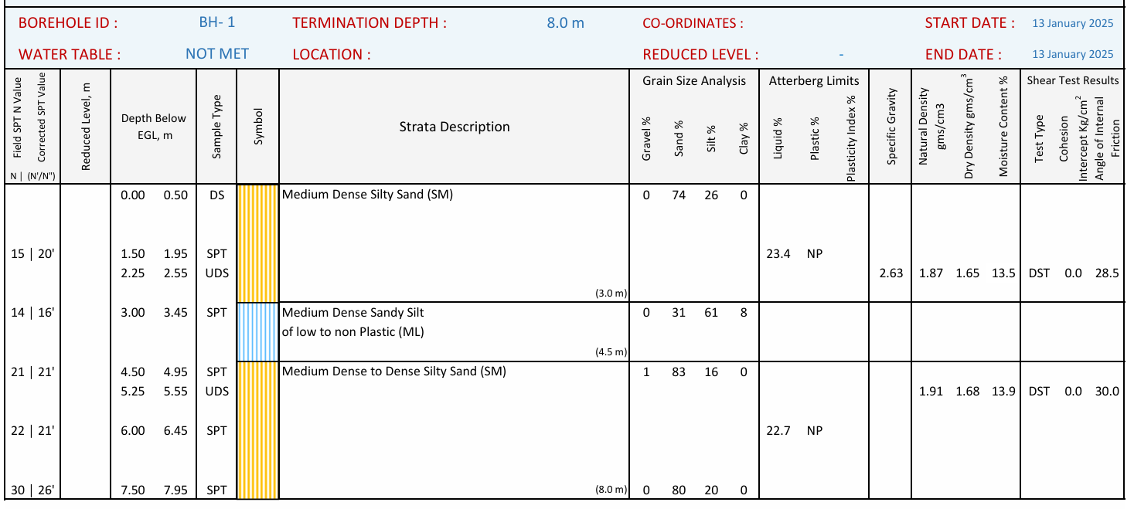

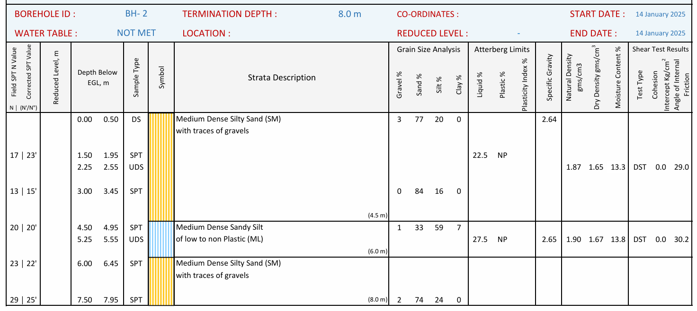

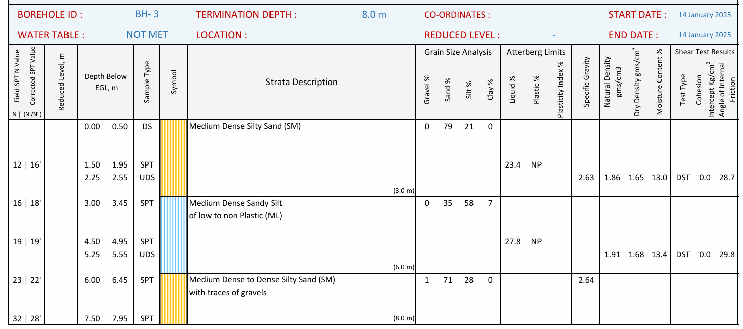

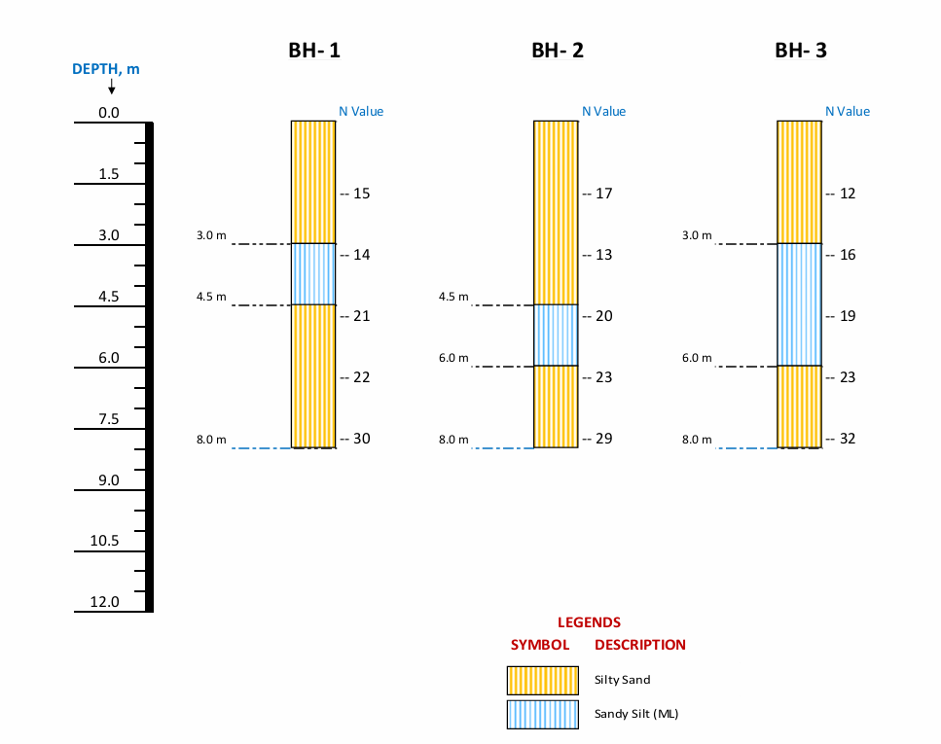
Figure 1 Summary of Borehole Profiles
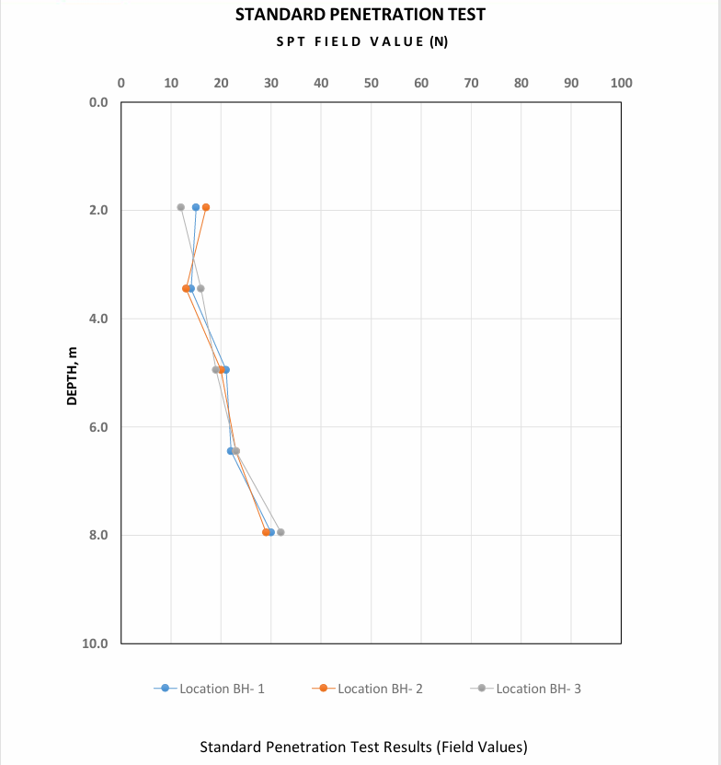
Figure 2 Standard Penetration Test Results (Field Values)
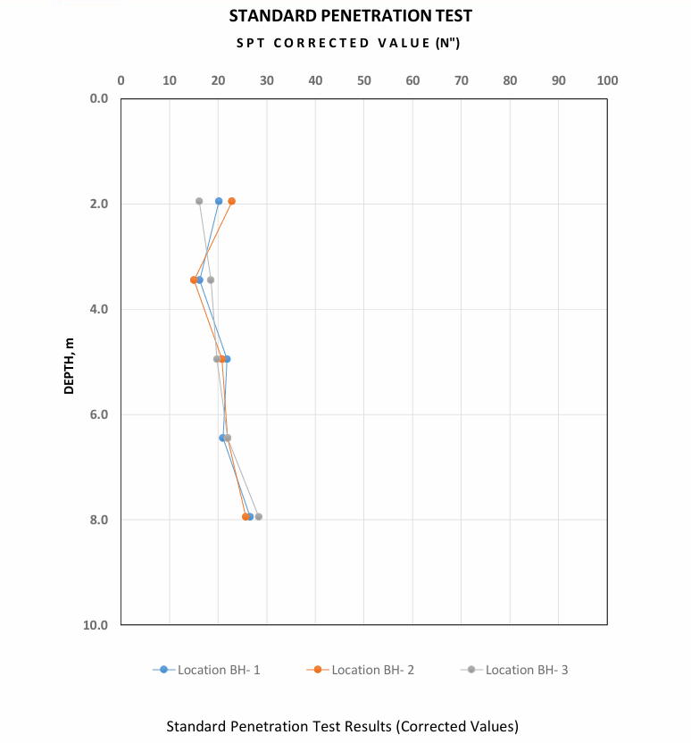
Figure 3 Standard Penetration Test Results (Corrected Values)
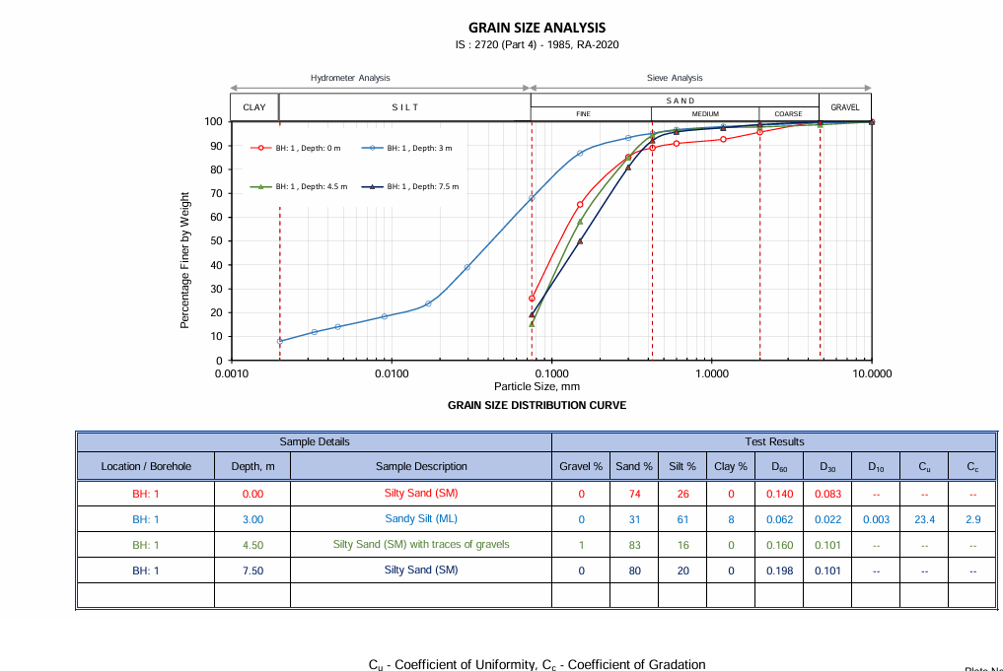
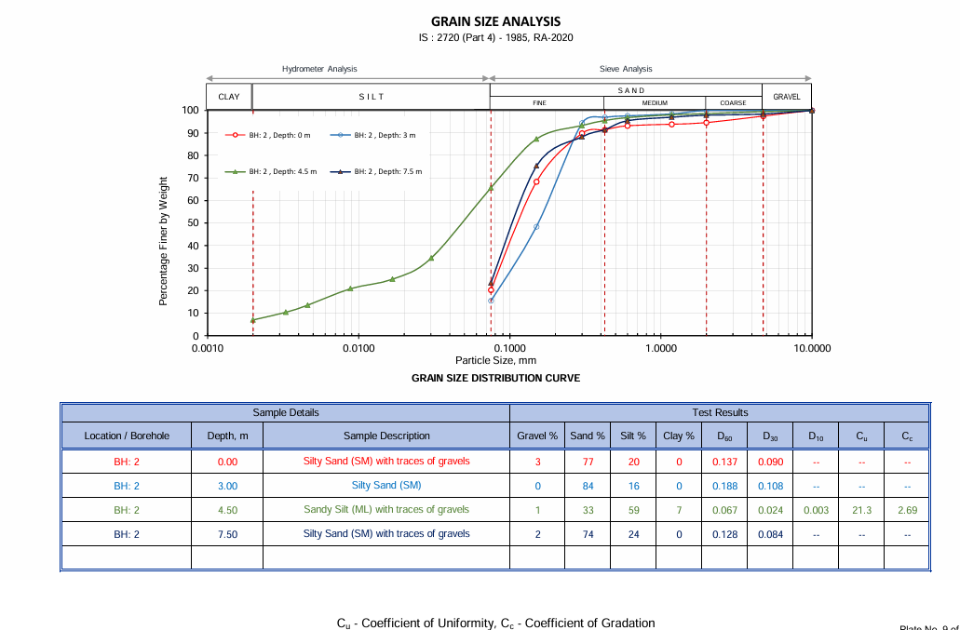
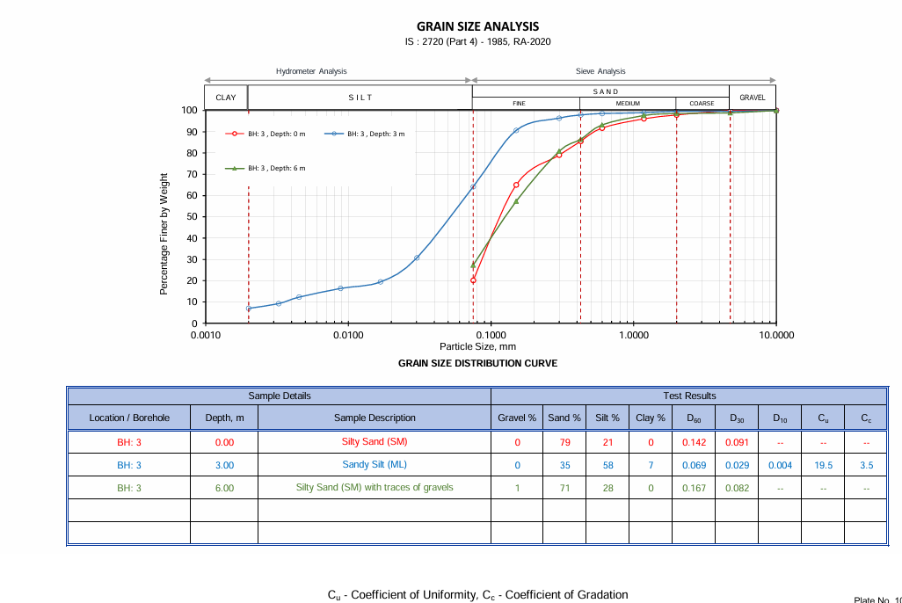
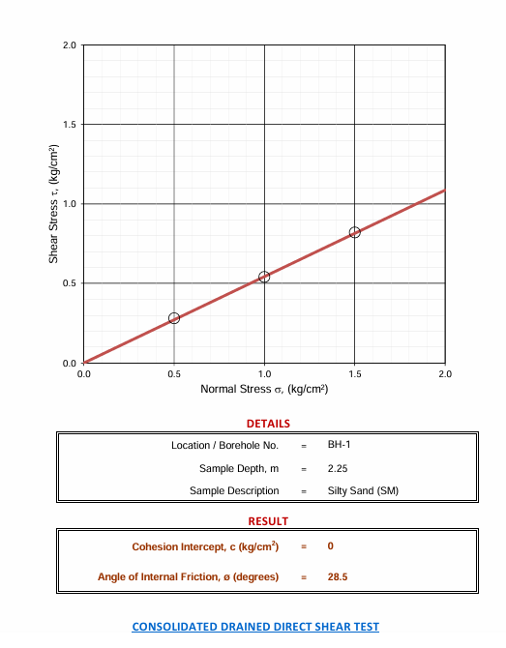

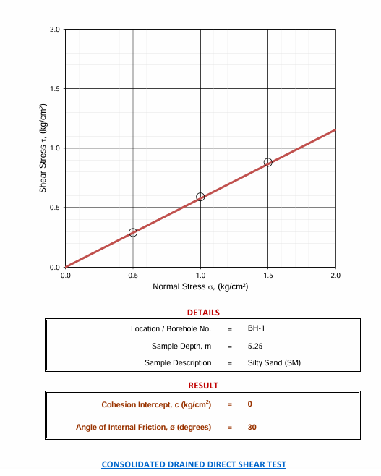
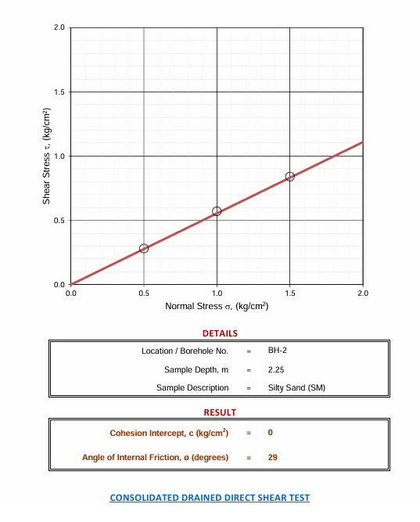
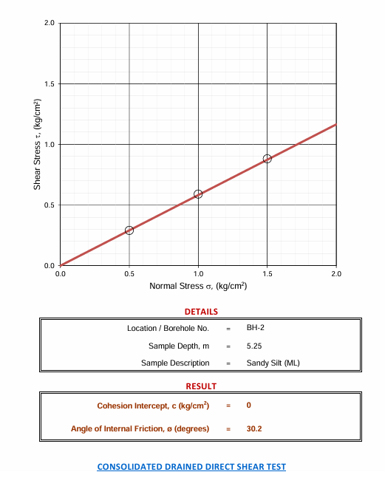
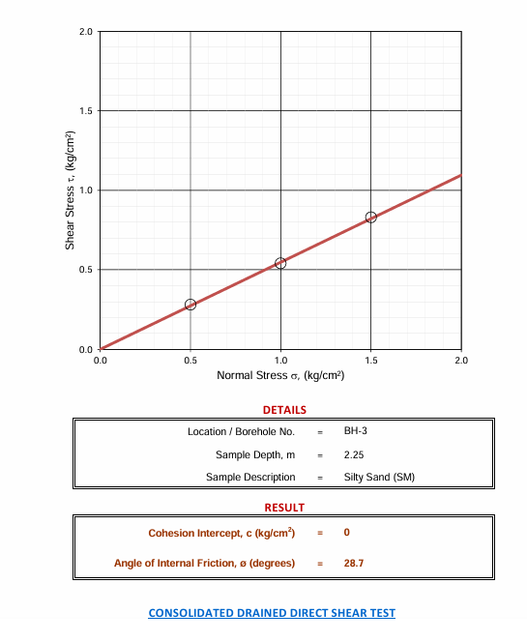

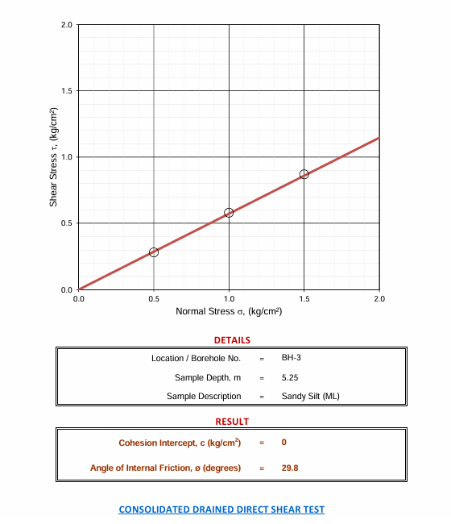

Use And Limitations

Intended use within the ToR

This annexure is provided solely to give tenderers indicative geotechnical information for the specific site of the proposed Agri‑PV project. It is intended to assist in preliminary foundation concept selection, estimation and bid preparation. Bidders shall review this information and use it, together with their own engineering judgement and design methods, to develop foundation solutions and ramming/embedment depths suitable for their proposed structures.

The Employer does not prescribe any particular foundation type or depth based on this annexure. The successful bidder shall remain fully responsible for the final foundation design, detailing and construction methodology, and for compliance with all applicable codes and safety factors.

Limitations of data and interpretation

The investigation results summarised in this annexure relate only to the specific borehole locations, depths and dates of investigation reported, and represent subsurface conditions at those points at the time of testing. Subsurface conditions at other locations across the site may differ, and conditions may change over time due to construction activities, seasonal groundwater fluctuations, flooding, erosion, seismic events or other natural or man‑made causes.

The data shall not be construed as a complete characterisation of all possible subsurface conditions or as a substitute for site‑specific verification by the bidder. If the bidder’s design methodology requires additional information (e.g. trial ramming, additional boreholes, load tests), such supplementary investigations and tests shall be planned and interpreted by the bidder’s own qualified geotechnical/structural engineer.

No warranty

The information in this annexure is provided in good faith, based on the original geotechnical consultant’s report, and in accordance with generally accepted geotechnical practice at the time of investigation. Neither the Employer nor the original consultant provides any warranty, express or implied, that the subsurface conditions are exactly as described at all locations or that no unforeseen conditions will be encountered. Bidders shall make their own assessment of the risks associated with subsurface conditions and allow for them appropriately in their bids.

https://mnre.gov.in/en/approved-list-of-models-and-manufacturers-almm/

